1. Write program to create menu

<html>

<style>

th

{

background-color:grey;

color:yellow;

}

</style>

<script>

function highlight(id)

{

document.getElementById(id).style.setProperty("background-color","blue");

}

function lowlight(id)

{

document.getElementById(id).style.backgroundColor="grey";

}

</script>

<body>

<p>Example for Menu</p>

<table border="1">

<tr><th id="t1" onmouseover='highlight("t1");' onmouseout='lowlight("t1");'>Create</th></tr>

<tr><th id="t2" onmouseover="highlight('t2');" onmouseout="lowlight('t2');">Insert</th></tr>

<tr><th id="t3" onmouseover="highlight('t3');" onmouseout="lowlight('t3');">Display</th></tr>

<tr><th id="t4" onmouseover="highlight('t4');" onmouseout="lowlight('t4');">Delete</th></tr>

<tr><th id="t5" onmouseover="highlight('t5');" onmouseout="lowlight('t5');">Exit</th></tr>

</table>

</body>

</html>

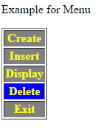

1. Printing Tree using DOM

<html>

<head>

<script>

function treeonline()

{

return subtreeonline(document.documentElement,0);

}

function subtreeonline(root,level)

{

retString="";

if (root.nodeType==1)

retString+=printName(level,root.nodeName);

var children=root.childNodes;

for(var i=0;i<children.length;i++)

retString+=subtreeonline(children[i],level+1);

return retString;

}

function printName(level, thisName)

{

var retString="";

for(var i=0; i<level; i++)

retString += "..";

retString += thisName+"\n";

return retString;

}

</script>

</head>

<body>

<p> This is paragraph </p>

<ol>

<li>One</li>

<li>Two</li>

</ol>

<form>

<button onclick="window.alert(treeonline());">Click Me</button>

</form>

</body>

</html>

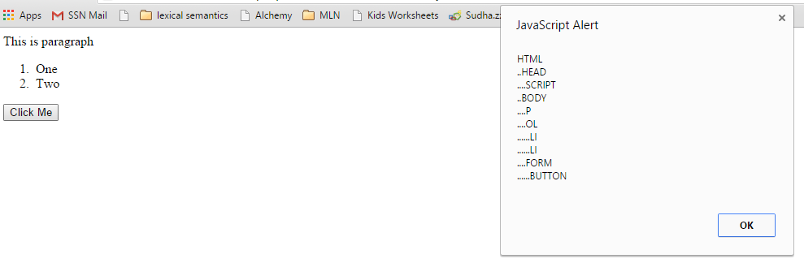





1. How to investigate the methods of Node Object?

<html>

<head>

<script>

function treeonline()

{

return subtreeonline(document.documentElement,0);

}

function subtreeonline(root,level)

{

retString="";

if (root.nodeType==1)

retString+=printName(level,root.nodeName);

if(root.nodeName=="OL")

{

alert("I am in <OL> node");

alert("Node type "+root.nodeType);

alert("Node name "+root.nodeName);

alert("Parent node "+root.parentNode);

alert("Chidren "+root.hasChildNodes());

}

var children=root.childNodes;

for(var i=0;i<children.length;i++)

retString+=subtreeonline(children[i],level+1);

return retString;

}

function printName(level, thisName)

{

var retString="";

for(var i=0; i<level; i++)

retString += "..";

retString += thisName+"\n";

return retString;

}

</script>

</head>

<body>

<p> This is paragraph </p>

<ol>

<li>One</li>

<li>Two</li>

</ol>

<form>

<button onclick="window.alert(treeonline());">Click Me</button>

</form>

</body>

</html>

1. How to add node in document tree (Collapse & Expand Program)?

<html>

<script>

function makeCollapsible(eltid)

{

var elt=document.getElementById(eltid);

var div=window.document.createElement("div");

elt.parentNode.insertBefore(div,elt);

var button=window.document.createElement("button");

div.appendChild(button);

button.setAttribute("type","button");

var buttonText=window.document.createTextNode("Click to Collapse");

button.appendChild(buttonText);

button.setAttribute("onclick","toggle(this,'"+eltid+"');");

}

function show(button,eltid)

{

alert("Hi");

alert(eltid);

}

function toggle(button,eltid)

{

elt=window.document.getElementById(eltid);

if(elt.style.display=="none")

{

elt.style.display="block";

button.childNodes[0].data="Click to collapse";

}

else

{

elt.style.display="none";

button.childNodes[0].data="Click to expand";

}

}

</script>

<body onload="makeCollapsible('o1');">

<ol id="o1">

<li>One</li>

<li>Two</li>

</ol>

</body>

</html>

1. Drag the item in tray

<html>

<head>

<style>

#div1

{

height:100px;

width:200px;

border:2px solid black;

}

</style>

<script>

function allowDrop(ev) {

ev.preventDefault();

}

function drag(ev) {

ev.dataTransfer.setData("text", ev.target.id);

}

function drop(ev) {

ev.preventDefault();

var data = ev.dataTransfer.getData("text");

ev.target.appendChild(document.getElementById(data));

}

</script>

</head>

<body>

<div id="div1" ondrop="drop(event)" ondragover="allowDrop(event)"></div>

<img id="drag1" src="bulboff.png" height="90" width="190" draggable="true" ondragstart="drag(event);">

<img id="drag2" src="bulbon.png" height="90" width="190" draggable="true" ondragstart="drag(event);"></body>

</html>